The Start of Something Smart, a Compilation of EDLD 5303

Regarding my class, EDLD 5303, this has truly been a learning experience. From day one, the expectations were clear, instructions were explicit, and I learned about effective classroom management I really didn’t know this was essential in the life of a good teacher. I was taught the teachers teach and students learn. Since this degree is being taught as online classes, there is no eye-to-eye contact, just zooms and written communication. Communication skills are necessary but having mastered communication, as the teacher, really makes the difference. I appreciated being treated as a real person. I wasn’t just another student, dreading each class. I was excited to be I this class from the beginning. I could feel the enthusiasm from the other students as well, but I think such a positive outcome was because of the teacher and his energy. Enthusiastic teachers promote student motivation and participation. I clearly saw this in the genuine, non-judgmental manner from our teacher.


Group discussions and participating is not easy for some. I know there were a few fellow students who did not want to have group projects. They wanted to work at their own pace and when they could manipulate their schedule. Some didn’t like to be told that they had to be in a group and actually have to show up at a specific time to work with their group. Personally, I welcomed the opportunity to work with my group. As a group of 4, we each brought our own thoughts, ideas and suggestions to the table. We each had worthwhile recommendations to complete our project: creating an ePortfolio. We were all curious and tried to look at formatting the ePortfolio from fresh angles. We were creative and worked together as a team. We had never met before, but collaboration can be very important. It was all done as a team. We talked, we listened, and we laughed, but we also got the job done. We accomplished all the requirements of the group assignments, each of us doing our part! We had our needed info together, on time, and we practiced like we knew what we were doing! I realize no two students are alike and adding technology made us all a little anxious, but, just like the real world, we stepped up and treated each other as individuals, very aware we wanted to be successful.

I think the group discussions helped us all to improve our communication skills (Harvard Division of Continuing Education, n.d.). I’ve learned that better communication skills are needed for success in the workplace. This class helped my ability to convey thoughts in a more polished technique. With each assignment, I found myself wondering “why” in the beginning, but in the end, I was able to put it in perspective. Thank goodness! With each assignment I could see improvement with student-teacher as well as student-student relationships and interactions (Prodigy Education, Inc., 2021). Pearson Assessments (2024) points out that “no two students are alike, but the same can be said for teachers”. This can make for difficult adjustments for everyone. I think this class had more positive exchanges than anything else.

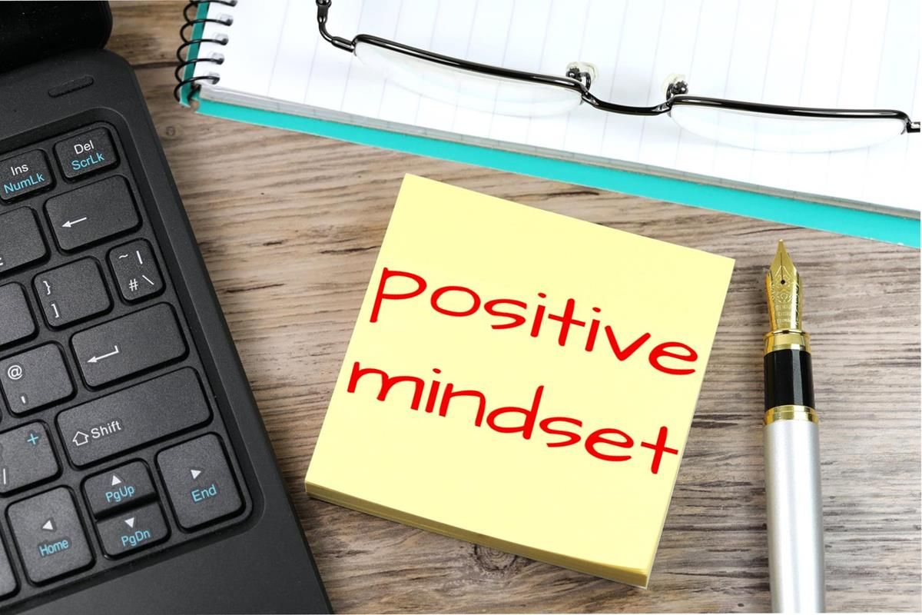
I know each day is difficult, but in the classroom, the challenges must be well, let’s say beyond belief, instead of difficult! I won’t be teaching children in an actual classroom but will have to work on the flexibility of any management plan. There was positive reinforcement within the social interaction during class. I saw that partition form some took a little effort, but it all came together as a positive learning session (Schools That Lead, n.d.). I work with fellows, becoming physicians, finding their passion, trying to cope with real life and I’m there to help as they move forward. I try to keep their stress levels normal and the burnout rates nonexistent, all while trying to keep my own sanity! Building positive relationships with these young people is one of the first things I try to accomplish when we meet. In this class, I did see positive reinforcement and that did help in my staying on task as well as my group. I think people as a whole, crave recognition, not just students. I motivate my fellows by recognizing the good and those are the things we all want repeated. If you see the good in people, tell them.
This is the first time to give a class compilation, but I did stop and go thru my notes, blogs and website to refresh my memory. Actually, this is my first class as I return from a five-year break! I am returning to finish my degree, and I’m glad this happened to be my class. I appreciate the teacher and his ability to reach each student. I never saw any discontent or any obvious frustration which made class time more relaxed, and I was more able to focus.
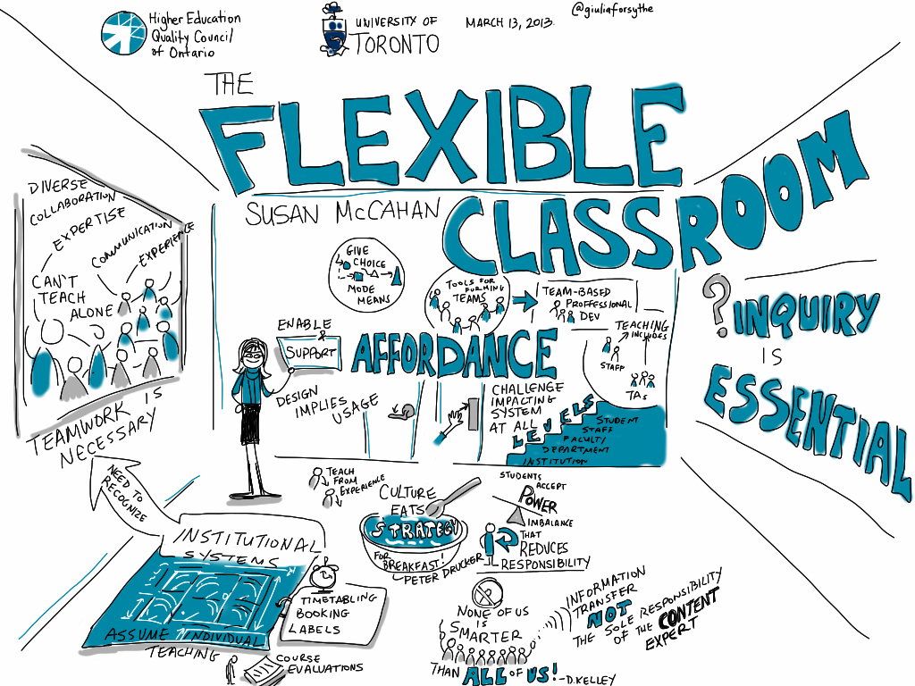
I saw clear expectations there were set early on. I believe there was positive student-teacher relationships. There was support if needed, with clear instructions to reduce the confusion. When things were going well, we were told, and I could see positive reinforcement. Our teacher listed. That’s important to me! Respect was given and shown throughout the class. In the old days, classrooms were managed by control. Today’s classrooms are on the internet, so communication, clarity, and consistency make a great classroom. Let’s not forget positive reinforcement and clear expectations because these encapsulate the tools need for successful teaching. And my class had all of these.
References

Harvard Division of Continuing Education. (n.d.). *Harvard Professional Development*. https://professional.dce.harvard.edu
Pearson Assessments. (2024, August 23). *Six elements of a well-managed classroom*. Pearson Assessments. https://www.pearsonassessments.com/professional-assessments/blog-webinars/blog/2024/08/-six-elements-of-a-well-managed-classroom.html
Prodigy Education, Inc. (2021, March 4). *Why student-centered learning is important and how Prodigy can help*. Prodigy. https://www.prodigygame.com/main-en/blog/student-centered-learning
Schools That Lead. (n.d.). *Schools That Lead*. https://www.schoolsthatlead.org

