Embracing Digital Learning: A Journey of Growth, Collaboration, and Leadership

When I signed up for this eight-week online course, I honestly wasn’t sure what to expect. I hoped to learn practical ways to use technology to help myself and others learn better and maybe figure out strategies to manage my own learning and growth. I also wanted to see how I could connect with my classmates, share ideas, and maybe even help them along the way. Mostly, I was looking for something that would give me tools I could use in real life—both for work and for keeping my own brain organized and on track. I hoped to come away feeling more confident in my learning, my leadership, and my ability to contribute to a community, even in an online setting.

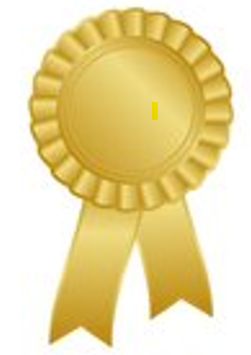
I will walk away from this class claiming it as a success. I truly enjoyed the assignments and discovering that I am a true GOLD! I also thought it was funny that three out of the four in my group were Golds as well. The group assignments really helped bring it all together. While our Zoom submissions were only about 25 minutes long, we often spent 1½ hours online talking, discussing, and strategizing. The ladies in my group are more than just group members—I think of them as friends, and we are all in this together. We text and check in to see how the week is going and make sure assignments are done and submitted. We are there to support each other, make sure everyone succeeds, and does well.

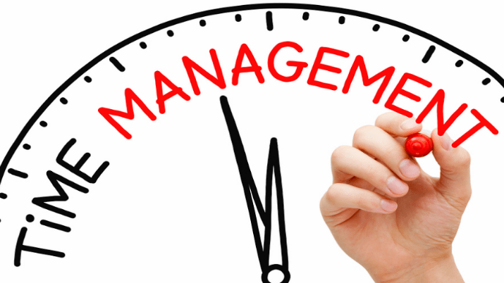
I don’t think anyone is perfect, and there is always room for improvement. Taking two classes in this eight-week block was a little tricky. With my classes starting, my daughter started her sophomore year of high school and is now showing rabbits in FFA. Life is a little crazy! I found that my lists don’t work if I can’t stick to them or even keep up with them. I realize I need to work on time management and making better use of my free time. For the next block of classes, I am planning to make a weekly schedule that includes work, school, and my daughter’s activities. I am going to schedule time for school and reading, instead of just “winging it.” Using the “wing it” method led to some late-night writing sessions, which were not fun! I just look at it as a small bump in the road to success. Fingers crossed that a better schedule will be the fix I am looking for.

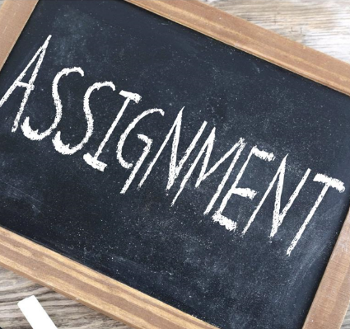
Over the last eight weeks, I have written and submitted 3 big assignments. The Technology Learning Manifesto, Personality & Leadership, and Technology Case Study Analysis. Each had some valuable take aways. The assignment, Technology Learning Manifesto, impressed upon me digital learning has provided us with opportunities to learn from different styles, and the variety enhances our knowledge acquisition. Learning should be an adventure, not a task and digital learning makes education more accessible. Education is moving more toward individualized studies, hopefully bringing back creativity and excitement. Learning in diverse environments, cultural competence enters in the skills and knowledge of the leaders to effectively assist students from diverse cultures. I think all students, when they are young, should be taught methods of change, making improved opportunities for all. Education should be accessible, even those with learning or physical disabilities. Digital learning has given us a step up, but it is not the final answer. Classrooms need to be flexible, yet personalized. Teachers should know their students. I still think educators play a pivotal role in shaping young minds. The early years set the foundation for lifelong attitudes and beliefs. Collaborative learning seems to be a great thing for all involved. The benefits are many with little to no negativity. More positive thoughts, actions and feelings about education is what we need.

In the lesson, Personality and Leadership, I took the Leadership Legacy, and it helped me understand myself more than I ever knew I could! I learned why I did some things and why I didn’t do others, and how to be more effective in my leadership skills. The test was an eye opener for me, and I thought it was very informative. I thought I was bossy, but I am inflexible! The good things I learned about myself helped me realize being a fair, openminded, responsible person is still a good thing, even in today’s world. I’m human and far from perfect but being transparent builds trust. Honesty is the finishing touch in being an essential part of my leadership.

In our final project, 1:1 Device Implementation, A Comprehensive Case Study for Digital Learning Success, the initiative was to seek and transform the learning experiences for 10,000 students in a mid-sized suburban school district, through the strategic integration of technology. The project addresses the digital divide by implementing a hybrid 1:1 device approach tailored to grade levels, which includes iPads for creativity-focused learning in grades 3-5, and Chromebooks for productivity in grades 6-12. A key component is a phased implementation roadmap, including infrastructure upgrades, professional development for educators, and robust student support systems. The project aims to boost student achievement, foster personalized learning, enhance digital literacy, and ensure equitable access to technology, ultimately preparing students for success in the modern digital economy.

I do believe showing your human side should go hand in hand with integrating technology into education. Human values in any situation lead to more positive outcomes, especially when the values are good, sincere and genuine. I think how you treat people in general adds depth to one’s personal wellbeing. When your true human side is showing, others seem to reciprocate. With proper resources, and appropriate teaching techniques introducing technology is what’s needed now, but it will be even more important in our future generations,

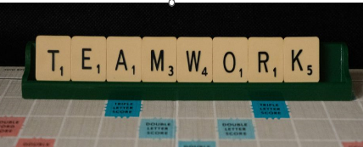
Going back to our groups, I truly enjoy this part of the class. I look forward to hearing what each person brings to the discussion. We are all in different roles, yet we all have so much in common. We each have learners who are depending on us, and we are here, in class trying to gain as much knowledge as possible to ensure that the next generation is better than we were. The group setting teaches you how to work with others which is necessary in education. You will always be working with others, and you will need to know how to work and get along with them. I enjoy the groups as they are and don’t think anything needs to be changed.

This course has also reminded me that being a self-directed learner means planning, reflecting on what works and what doesn’t, and taking ownership of my learning. I’ve learned the importance of balancing responsibilities, asking for help when needed, and actively contributing to a learning community. My experience in the group discussions, the assignments, and even the small daily routines I adopted has strengthened both my confidence, and my ability to collaborate effectively with others. I feel that I have not only grown personally but have contributed meaningfully to the success and learning of my peers.

