**Why, How and What we do to Stay Ahead of the Game**

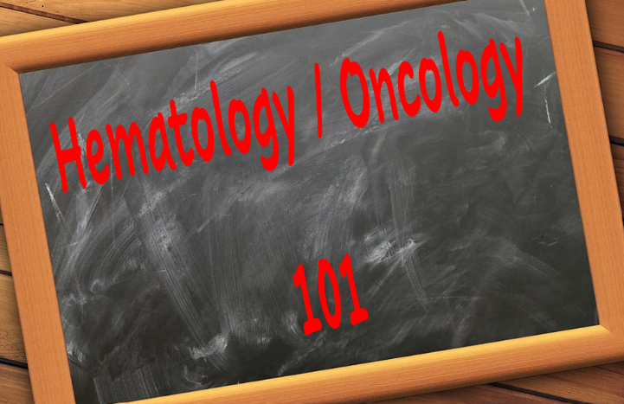Working in the hematology/oncology fellowship program of M D Anderson Cancer Center, here in Houston, I know the importance of preparing physicians for the evolving realities of medicine. Our fellowship program is three years long, structured with clear learning objectives and evaluation processes. Fellows are required to attend in house didactic lectures all day, every Tuesday. This is just one of many learning opportunities we offer, including in‑house lectures, Zoom sessions, in‑training exams, and bedside teaching.

Our fellowship has evolved through the years and so has our approach to teaching. The years of a teacher saying and student doing without questions or my rules-you will accept and go along with …. are long gone! Always looking to the future, we put the interests and concerns for our hospital and patients first and then the next stage is continuing excellence. We must pursue change intently and accomplish with actions, not just words. Our objective is helping house staff, faculty, administrative and classified employees evolve. If we can understand how people learn and develop in a situation, we can better help them.

Learning causes stress and it requires effort. To get this far into their medical careers, these fellows must already have the drive needed to succeed. They WANT to be here. They are here to learn and will adapt. They will bring in their own experiences and expect respect for their past knowledge, wanting their skills to be used and recognized by the organization. All this comes into play when asking them to develop into new roles and responsibilities. This is why a give and take setting becomes amicable.

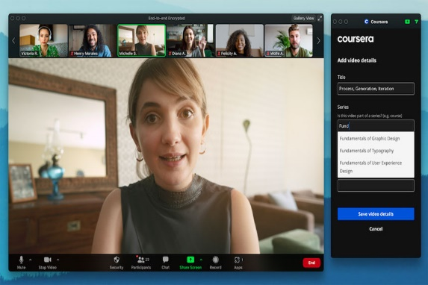By designing a dynamic curriculum that blends in person clinic with virtual learning modules, incorporating live and recorded lectures from global experts, blended learning design seems to work best currently. Continuing feedback from the fellows and faculty improves the balance between flexibility, rigor and real-world readiness. Our students receive more customized, engaging, and effective learning experiences which helps them learn individually and collaboratively (University of Massachusetts Boston, 2025). Instructions modify the requirements of specific learners by understanding how the students learn and process the information. This often makes the atmosphere more engaging and dynamic, utilizing a range of teaching techniques, such as practical exercises, group projects and 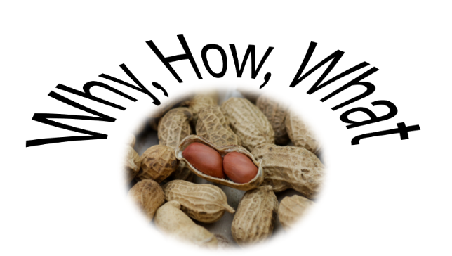technology-based learning (Creatrix Campus, 2023).

There is a huge difference in conventional and contemporary education. Traditional or conventional education is teacher centered, while contemporary education is student centered. We’ve learned contemporary education incorporates technology, problem solving and personalized experiences all preparing students for an ever-changing world. Contemporary education prioritizes the holistic development of students, which includes their social, emotional and physical wellbeing, alongside their academic growth. At this point and time, I would like to continue our method of contemporary teaching with a few tweaks, as it seems to be the most beneficial to all. With this new class of fellows that just started, we are bringing in our “chalk talks” and hybrid learning. Experts are being brought in from around the world to share and exchange their knowledge to help accomplish our mission of curing cancer. The chalk talks ensure every participant contributes their thoughts and ideas. This format involves an educator or researcher discussing their goals verbally, making for dynamic and interactive discussions.

I feel our fellowship program has progressed substantially just since I’ve been here. For fifteen years I’ve detected the developmental changes made. These changes have included physical, cognitive, emotional and social development. Our aim has always been to make things better. Development change is usually less disruptive than other types of change and tends to be met with less resistance from individuals or groups. I think this is the “WHY, HOW and WHAT” process in a nutshell! Our system of teaching may not be perfect, but it is on track and always open to innovative ideas. That is how we stay ahead of the game.

**Resources**:

University of Massachusetts Boston. (2025, February 19). *How education has adapted to a world that’s constantly changing*. UMass Boston Blogs. <https://blogs.umb.edu/>

Creatrix Campus. (2023, May 11). *Revolutionizing education: The role of pedagogy in modern learning and technology*. <https://www.creatrixcampus.com/>